

Stock market platform

Student: Martuneac Alexandru

Group: 30431

# Vision

## 1.1 Introduction

Stock market platform is a web application which will offer business owners the possibility to publish IPO (initial public offering) and facilitate investors to buy or sell stocks from different corporations.

### 1.2 Positioning

The problem that this project is aiming to solve is the lack of “broker-less” ways of investing in our country. As solution, we will create a web-application which will contain a variety of companies to choose from and allow different operations for investors (buy & sell) and business owners (perform n-1, 1-n splits). Furthermore, this project allows business owners to open separate accounts to invest as well.

#### 1.3 Stakeholders

The stakeholders for our product are every business owner that wants to list their company and the investors.

##### Use Case Model

###### Specification

|  |  |
| --- | --- |
| **Goal** | Search for a company and perform an operation |
| **Actor** | Investor |
| **Success Scenario** | The user will search for a company, either by the name of a specific tag. From there, an investor can choose either to buy or sell stocks from that company. A message that the action has been completed successfully will appear on the screen. |
| **Error Scenario** | The company is not listed on the platform and an error will appear. If transactions are done outside trading schedule, a message pending will appear. The transaction will be queued and performed when the market re-opens. |

|  |  |
| --- | --- |
| **Goal** | Perform splits |
| **Actor** | Business Owner |
| **Success Scenario** | The number of shares for a company will multiply or decrease. A message will appear on the screen to all investors that hold stock from that company. |
| **Error Scenario** | Splits cannot occur twice in a day. A message will appear on the screen to inform the business owner. |

|  |  |
| --- | --- |
| **Goal** | Buyback stocks |
| **Actor** | Business Owner |
| **Success Scenario** | When a buyback operation is performed, the company will buy shares from sellers. |
| **Error Scenario** | Display a message that no seller or stock is available. |

* 1. Diagrams

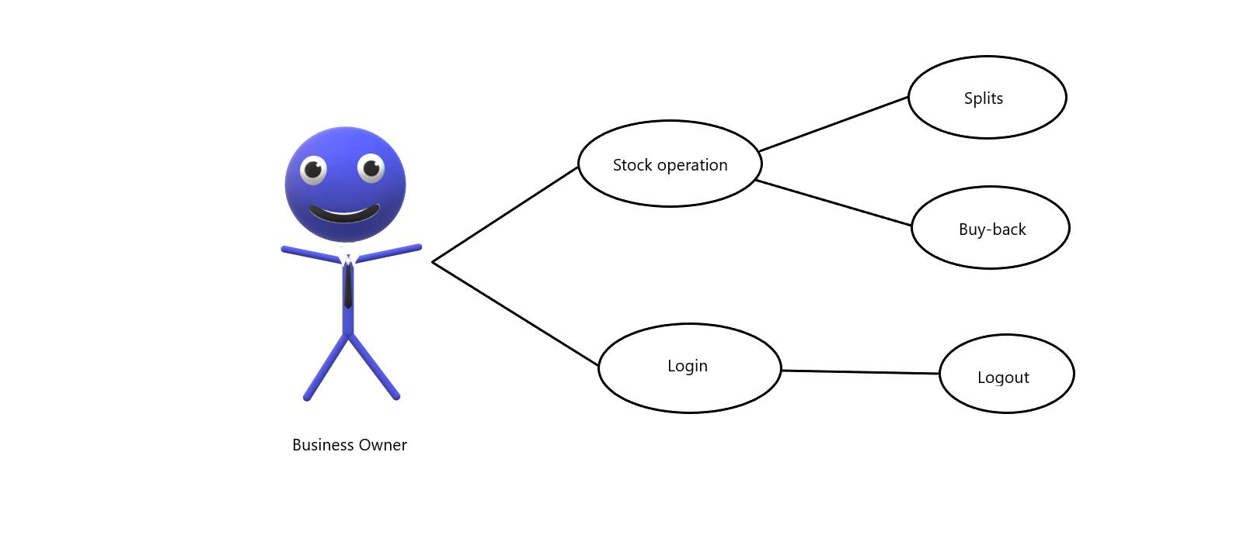

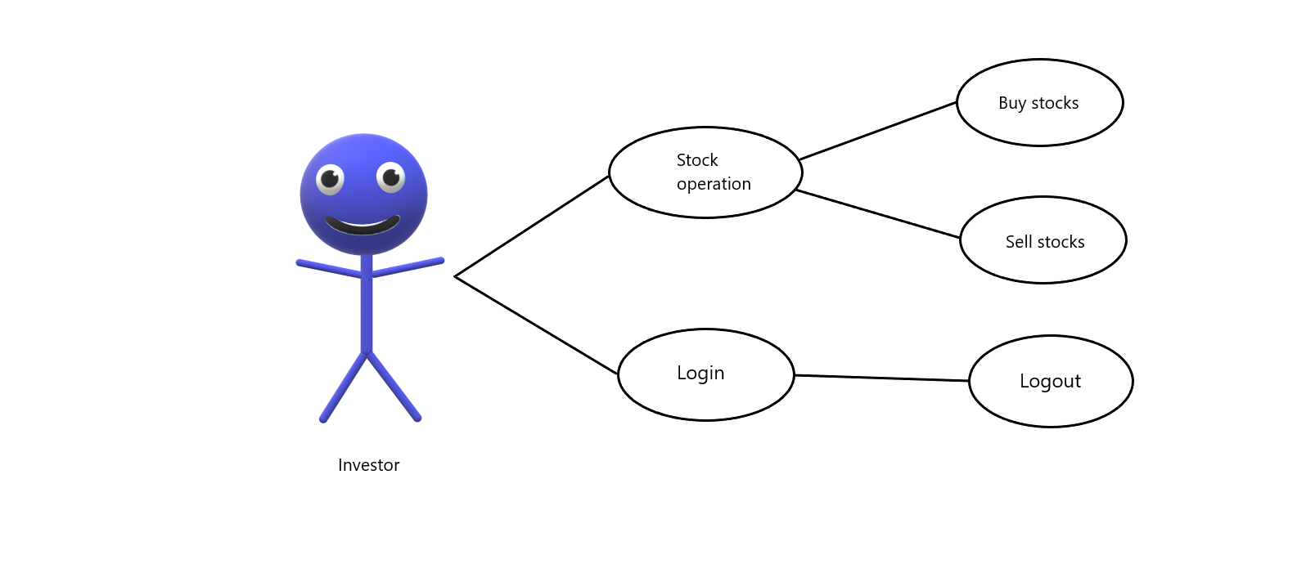

# Supplementary Specification

## Non-functional requirements

Each user will have to register and login onto the website. The registration is done by choosing a username and a password and an account type.

## Design constraints

Layered architecture

Web application

Developed with Java 11 and Spring Boot.

# Glossary

## IPO

The process of offering shares in a private corporation to the public for the first time.

## Stock split

Corporate action in which a company divides its existing shares into multiple shares to boost the liquidity of the shares. Although the number of shares outstanding increases by a specific multiple, the total dollar value of the shares remains the same compared to pre-split amounts, because the split does not add any real value.

## Stock buyback

Stock buybacks refer to the repurchasing of shares of stock by the company that issued them. A buyback occurs when the issuing company pays shareholders the market value per share and re-absorbs that portion of its ownership that was previously distributed among public and private investors.